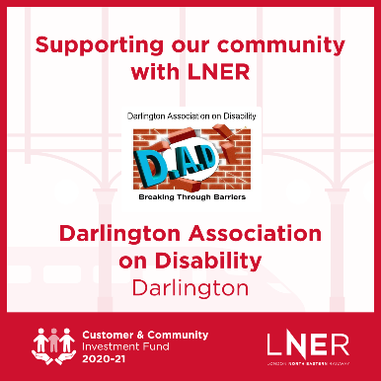
Positive Travel Project
in association with LNER

Are you a disabled adult, child or young person? Are you a parent or carer who supports a disabled adult, child or young person?
If so, we need your help!
The aim of the project is to support disabled people and carers of all ages to tackle the barriers they face in accessing transport and travel.
We want to know about your positive experiences and any barriers you have faced whilst accessing public transport locally, regionally or nationally.

What works well? What does not? What specific barriers have you faced? What can be improved?
If you can spare a few minutes of your time, please email or call
david.thomas@darlingtondisability.org / 01325 489999
All feedback will remain anonymous

Registered Charity No. 125848
Company No. 6688735

