Darlington Association
on Disability

Centre for Independent Living

Breaking through Barriers

Impact Report

Darlington Association on Disability is an organisation led by disabled people, which exists to promote independence and choice.

DAD supports disabled people and carers through the provision of services, support and information and by tackling issues affecting disabled people both locally and nationally.

Chair’s report 2013 – 2014

It is with great sadness that I start this report by recalling that it was within this time period that Darlington Association on Disability (DAD) lost one of its most treasured and loved members of staff, Assistant Chief Executive Jacki Hiles. Jacki’s death was a great blow to the organisation and her knowledge and expertise has been sorely missed.
Changes brought about by welfare reforms and national and local cutbacks have made for an extremely worrying time for disabled people and carers as well as organisations like DAD. However as a leading disability user led organisation I am committed to DAD ensuring that disabled people and carers are fully involved in any decisions that affect them.

The demands on DAD’s services have continued to increase at a time when financial support is getting more and more competitive and harder to come by. I express my extreme gratitude to all our financial supporters, especially in these difficult times of uncertainty, and offer them my sincere thanks. Getting financial support is a struggle, nevertheless the reports from the different projects within DAD show many positive outcomes for disabled people and carers.

Management, staff and volunteers have worked extremely hard to ensure DAD fulfils its commitments to people. They have not only supported disabled people and carers but also each other and the organisation with many going that extra mile above and beyond as the demand on our services have grown. I am immensely grateful to them for all for their loyalty and dedication and offer them my heartfelt thanks.

I acknowledge the role played by Chief Executive Lauren Robinson along with senior managers Tracy Roberts and Rosemary Berks and I thank them for their hard work, commitment and professionalism.

I am immensely grateful to my fellow trustees for their time and hard work that often goes unseen by most. I also thank them for their continued commitment to DAD.

Gordon Pybus

Chair, Darlington Association on Disability
Advocacy

DAD supports disabled people and carers to say what they want, secure their rights and get services that they need. DAD also encourages self-advocacy.
Examples of our work in this area include:

- Running and developing the new DAD Advocacy Project, which started in April 2013, bringing together an experienced team of advocates and supporting many people through a steady stream of referrals and self-referrals
- Supporting Darlington’s People’s Parliament, a self-advocacy group for people with learning impairments. Members have delivered workshops, training and awareness-raising events covering Self Advocacy, Hate Crime and bullying
- Encouraging people at the Independent Living Hub to improve confidence-building skills as a step towards using their experience positively
- Working with disabled people and parents of disabled children to ensure their views are included in the assessment process
- Supporting people to challenge financial decisions made during the assessment process which impact on their ability to live independently
- Supporting people to challenge discrimination
- Providing rights based information and support to enable disabled people and carers to self-advocate
- Developing and maintaining a confidential database to allow the storing of information securely.
- Training Advocates and other staff and volunteers across the organisation to complete training in National Advocacy Qualification NVQs, all achieving Level 2 Certificate in Independent Advocacy, others going on to Level 3 Diplomas in Independent Advocacy.

‘Advocacy is about enabling every person to have a voice of their own and ensuring that they are not excluded because they do not express their views in ways that people understand’ (A voice of their own, BILD, 2006)

Access

DAD brings disabled people together to improve access by addressing barriers created by both the physical and attitudinal environment. It does this by promoting good practice around access issues, and by working with planners and providers to improve access to services. DAD also advises public bodies on how to carry out the duties imposed on them by the Equality Act.

Examples of our work in this area include:

- Meeting with planning consultants and architects for a new town centre leisure development in Feethams, resulting in revision to the designs including ramps to ensure the area will be fully accessible.

- Ensuring that planners took into account access legislation and the Equality Duty when making decisions about Town Centre planning applications.

- Supporting with issues around legal fees in an alleged workplace discrimination case.

- Supporting a group having difficulties with a proposed path and gateway at Maidendale Nature and Fishing Reserve. Plans were changed to alter the path and to use different materials to make it more accessible.

- Working with a bank on High Row to improve their access and services for disabled people, with the result of having a new lift installed.

- Assisted the council’s highways department with advice on dropped kerb allocation and updated a disability access audit of the Town Hall.

- Advising on planning applications. As a result a new café near the marketplace installed a ramped entrance and a wheelchair accessible toilet. The proprietor said the first day when the ramp was completed he had eight wheelchair users accessing his café.

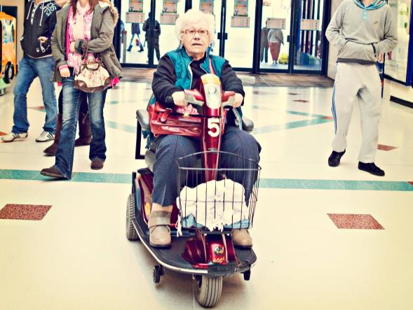
Campaigning

DAD is a non-political organisation; however it actively campaigns on issues which affect the lives of disabled people, families with disabled children and carers. DAD listens to its members and tries to influence decisions that are being made at a local and national level. Some examples of our work in this area are:

- Coordinating responses and getting people involved in various public consultations

- Gathering evidence and making the Council and other public bodies aware of the impact of the cuts on disabled people and carers.

- Supporting young people to speak out about issues that affect them.

- Campaigning at a local and regional level for improvements in the way that disabled people who are the victims of hate crime are supported, and supporting the Police Hate Crime Advisory Group.

- Releasing statements and articles on issues faced by disabled people and carers, for example, transport issues, particularly wheelchair users using taxi / private hire vehicles, including access and how fares are calculated.

- Co-ordinating a DAD response to the Council’s draft Discretionary Housing Payment policy, to ensure disability issues are understood.

- The Direct Payment Support Service hosted a disability impact assessment meeting, which was well attended by direct payment users. The Commissioning Manager from Darlington Borough Council attended to obtain views

“I personally would not have managed without the help I have received in the past and present and it is more than likely I will be needing their help in the future, and I know they will be there.”

Peer Support

DAD offers opportunities for disabled people of all ages and carers to learn from one another, and to work together to tackle issues. This is called peer support.

Examples of our work include:

- Facilitating a number of groups for carers, who are often isolated by their caring role, bringing people with similar experiences together.

- Bringing people who use Direct Payments together for peer support in a regular monthly group meeting, enabling them to share experiences and influence service development.

- Recruiting young disabled people as volunteers on DAD’s playschemes, enabling them to develop skills as peer mentors and providing disabled children with positive role models.

- Enabling members of the Independent Living Hub to support each other to build confidence and find solutions to barriers which impact on their independent living.

- Running a Young Leaders group which enables young disabled people aged 14-25 to develop confidence and skills and gives young people a voice

- Continuing to develop the Stronger Voices…Strong Support project, focussing on providing peer support and delivering training to staff and volunteers. Disabled people and carers supported by the project reported increases in knowledge and confidence and became much more active in completing self-assessments and leading the social care assessment process

- Co-facilitating a series of information and Peer Support workshop events, including sessions with other user-led organisations in Newton Aycliffe, Hartlepool, Sunderland etc.

“You never just get left to cope on your own once you’ve asked for help; most of the time they go above and beyond what other organisations would do. They keep in constant contact and always check if you’re doing OK and are coping with everything.”
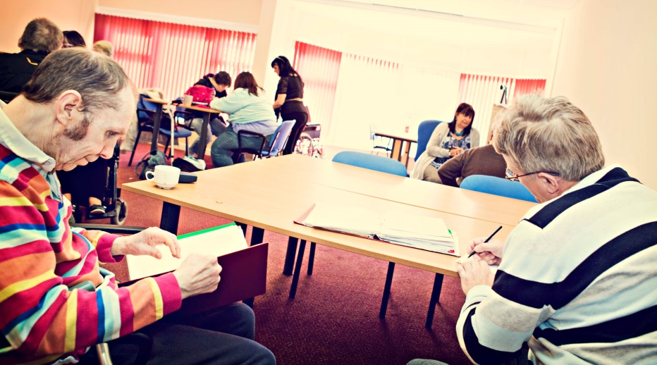
User Led

DAD is a user led organisation (ULO) which is run and controlled by people who use services, including disabled people, mental health service users, people with learning impairments, their families and carers. (Definition provided by the Social Care Institute for Excellence, 2009). This is fundamental to the way that DAD works, as it means that people who use services direct and influence the organisation at all levels.

In order to meet this vision DAD:

- Has retained a longstanding commitment to being user-led, by enabling DAD to develop from a small charity led by disabled people, to a company limited by guarantee with a Board of Trustees, the majority of whom are disabled people, who direct the work of DAD

- Is committed to develop and implement policies which actively support the recruitment and retention of disabled people as staff and volunteers

- Works with young people to produce leaders of the future; supporting them to get involved at all levels within DAD – as volunteers, staff and potential Trustees.

- Facilitates a regular Stakeholder Forum where any member of DAD can raise issues of concern and consulting widely with our members

- Delivers training through projects such as Stronger Voices... Strong Support, recruiting people as trainers and volunteers who themselves have planned their own support and therefore have first-hand experience

- Involves disabled people in all recruitment and selection decisions.

- Invited to present our work at an event for Disabled People’s Organisations, organised by the Governments Office of Disability Issues in Newcastle. DAD received very positive responses from the organisers and delegates for being a non-impairment specific user led organisation.

“A ULO is an organisation based on clear values of independence, involvement and peer support. Unlike other voluntary sector organisations, service users control the organisation. ULOs are uniquely identified by their knowledge, which is based on direct, lived experience. These three criteria define a ULO” (Shaping Our Lives 2009)

Co-production

DAD supports and encourages co-production, ensuring that disabled people and carers are involved fully and at the earliest possible opportunity when policies or services are being developed.

Co-production refers to a way of working where decision-makers and disabled people and / or carers work together to make a decision or develop a service which works for everyone. Co-production is built on the principle that those who are affected by a service are best placed to help design it.

Examples of co-production include:

- Working with the People’s Parliament to enable people with learning impairments to develop skills which they can use to co-produce local services, delivering training to health facilitators and getting involved in consultations.

- Supporting carers who sit on the Carers Strategy Steering Group, which determines how services for carers are developed and delivered in Darlington

- Championing the Co-production model with Darlington Borough Council as a way to effectively develop personalisation locally

- Ensuring that parents of disabled children have opportunities to influence the development of the local Special educational needs (SEN) Pathfinder programme

- Involving disabled people in the design of new buildings and in planning forums where they can influence decisions about access and service delivery

- Developed a Living and Learning training programme in consulting with disabled people and carers, employers and PAs to identify training needs and tailoring courses to suit people’s requirements and schedules.

“I now have more confidence to talk to Doctors and consultants. I have realized that I am the professional in my caring role, not them.”
Training

DAD organises and offers training on a wide range of topics to practitioners and advisers, voluntary sector organisations, disabled people and carers. The purpose of training has been twofold – to increase the knowledge and skills of staff and volunteers within DAD in order to deliver the best possible service, and to improve the lives of disabled people and carers by providing them with a range of training.

Examples of training delivered to staff, volunteers and members during the year include:

- Disability Equality and Equality Act 2010
- National Advocacy Qualification (NAQ) training
- Personal Independence Payment (Disability Living Allowance) training
- Inclusive Play and Disability Awareness delivered by Young Leaders
- 7 Steps of Personal Budgets and sessions on developing Support Plans
- Non-violent Crisis Intervention training
- Keyworking In Participation training for practitioners and parent / carers
- Advice, Telephone and Listening Skills
- Safeguarding training, mentoring
- Skills For Carers courses for carers health and wellbeing, including sessions on confidence building, managing stress, health checks, relaxation techniques, practical techniques for coping with caring
- The Living and Learning Programme, a Skills For Care project which delivered 47 courses tailored to employers and Personal Assistants, through a combination of internal and external trainers, including a range of subjects, from budgeting and HMRC tax payments to Basic First Aid, Healthy Eating and Mental Health Awareness

”I am pleased that I came on the course, this has helped my confidence and I have found new friendships by participating.”

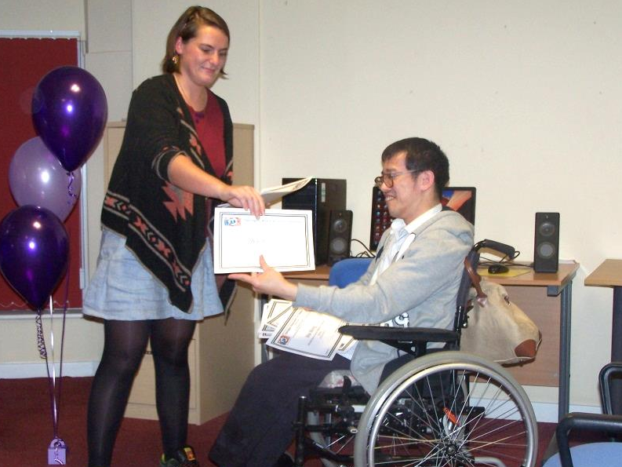
Personal Budgets and Direct Payments

DAD is committed to disabled people, parents and carers having more choice and control over the assessed services they receive. DAD offers information, advice and support to people to explore and use Personal Budgets, Direct Payments and Personal Health Budgets. Staff can also assist with the self-assessment process and support planning. Some examples of our work are:

- Running a full payroll service and a robust recruitment service, supporting people with direct payments to advertise, vet, recruit and employ their own Personal Assistants

- Operating managed accounts that provide an opportunity for people to have a direct payment without the additional responsibilities of managing their finances

- Enabling disabled people and carers to explore imaginative and cost effective ways to receive assessed services. Examples include using singing lessons for socialising and improving confidence, short breaks for a disabled person and carer for respite and to visit family,

- Supporting direct payment users to pool budgets and share support. This can be a great way to get the most out of a direct payment, for example: forming a sports or social group and purchasing equipment, paying for a holiday or short break, going on trips or excursions, or pooling the support from a personal assistant. This also allows people to form new relationships and have new social opportunities.

- Delivering training in employment subjects such as budgeting and HMRC payments

‘My lead worker visited to explain how my budget works and provided the support around the reduction in the sleepover rate. I am very happy that I now know what’s happening and what I need to do, your support has taken one of my anxieties away.’

Choice, Control, Flexibility and Inclusion

As a Centre for Independent Living (CIL) DAD provides unique practical services which enable disabled people and carers gain and maintain control over their life. People using DAD have access to a wide range of support, including personal assistance, person centred support services, information and advice, co-production and training.

Some examples of our work in this area include:

- We received an award from the Newcastle Building Society for being the ‘Cornerstone of the Community’. This awards scheme has been introduced by the Society to reward people or organisations that have made a significant contribution to their local community. Nominations were made by customers and members of the public. DAD’s Independent Living Hub received this award, in the business category, for the support we give to disabled people within our community. Particular mention was given to the outstanding support opportunities we offer to enable access to education, leisure and employment.
The award was accepted by members, volunteers and staff of the hub at a ceremony of celebration.

- Offering up to 10 free sessions at the Independent Living Hub funded through the Clinical Commissioning Group, Carers short break funding

- Developing an outreach service so that people can receive support to access independent living, community and leisure services. The Independent Living Hub has also expanded to include support outside of the Hub and at evenings and weekends.

- Increasing the range of equipment available through Shopmobility, including short-term and long -term loans

- Delivering a range of holiday activities through DASH playscheme

- Offering a wide menu of support to people using direct payments, including a robust recruitment service that helps people advertise for personal assistants

- Working together to add value to the service we provide. Examples include providing an information service alongside Shopmobility to enable first time customers to explore other sources of support.

“The Independent Living Hub has given me the chance to access educational programmes and social activities which has improved my communicational skills and life. Instead of being at home it has enabled me to go out more in the community. I have completed several courses in Customer Care, Equality and Diversity. This has increased my knowledge and understanding. I find the staff and members friendly at the Hub!”

Information and Advice

DAD provides comprehensive, up to date information and advice on a wide range of topics. The organisation also supports disabled people and carers to make informed choices and increase independence through access to disability rights based information.

Some examples of our work in this area are:

- Enabling disabled people to get free high quality specialist legal advice, increasing their understanding about their rights and how to challenge decisions

- Providing information and advice to people on a wide range of topics ranging from independent living, housing, social care, adaptations and equipment, education and welfare rights.

- Working with other local services to deliver information and advice at community events throughout the Borough

- Providing information in a range of formats, including large print and audio versions of leaflets, fact sheets and newsletters

- Delivering training to increase staff and volunteer knowledge and understanding, allowing them to pass on more information, including the Equality Act 2010, welfare reform and changes in the welfare benefits affecting disabled people.

- Supported people to secure grants, appeal Employment Support Allowance decisions and to challenge reduction of discretionary housing payments, council tax and disability related benefits

- Devised a screening process for front line staff and flowchart for the provision of information and advice across DAD, ensuring that some enquiries can be managed by staff within other projects or signposted to appropriate services.

“When I have required information or help, I have always been informed of everything that DAD can help me with and if they get more information they let me know. They put me at ease and I always know they will do their upmost to help, no matter the reason why or what I’ve asked for help with.”

DAD Services

Access Interest Group brings disabled people together to improve access for disabled people by addressing physical and attitudinal barriers.

Advocacy Project is a free and independent advocacy service for individuals and carers.

Carers’ Support Service provides free information and advice to anyone providing support to a family member, friend or neighbour because of age, illness or impairment.

Children and Young People’s Service provides inclusive and accessible play and leisure opportunities and support. It runs DASH inclusive play and leisure sessions during holidays for disabled and non-disabled children between the ages of 3 to 16 years.

Direct Payments Support Service provides a range of support about Direct Payments; one way to get more choice and control over social care support.

Information Service provides disability information and advice on options.

Shopmobility Service provides the loan of manual and electric wheelchairs and mobility scooters in Darlington Town Centre for anyone with a mobility impairment.

Volunteer Project recruits and supports volunteers to work in DAD

Independent Living Hub offers support to disabled people to increase self confidence; to identify and work towards personal goals. It also offers opportunities to meet new people, peer support and take part in a range of social activities.

Stronger Voices… Strong Support for disabled people who have used personal budgets to support others through advice and guidance, workshops, peer support and mentors.

Equal Access to Information and Advice Project supports disabled people and carers to make informed choices and increase independence through access to information about rights.

Financial Information

The following figures are taken from the Report of the Trustees and Financial Statements for the year ended 31st March 2014 for Darlington Association on Disability.

Income
The following graph shows the breakdown of Total Income of £1,096,203 split into:

Voluntary Income Grants - £5,257
Fundraising Income - £240,466
Bank Interest - £544
Project Income - £849,936

Financial Information

Expenditure
The following graph shows a breakdown of the Total Expenditure £ 1,130,639 split into:

Project Costs - £1,008,467
Support Costs Management - £4,867
Depreciation - £2,638
Fundraising & Governance Costs - £114,667

