Darlington Association on Disability
Job: Co trainer

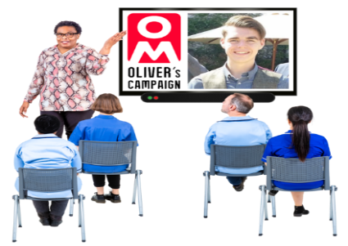 | We want people who are already an Oliver McGowan Mandatory Trainer on Learning Disability and Autism or people who would want to learn how to be one.  Only people who have a learning disability or are an Autistic person can do this job.  You do not need a formal diagnosis though.
 | This training helps health and social care staff to understand how to better support autistic people and people with a learning disability.
 | Co-Trainers will share some of their personal experience to help these health and social care staff understand how to support people who have a learning disability or Autistic people.
 | Co-Trainers will need to be able to work with other people as part of a team.
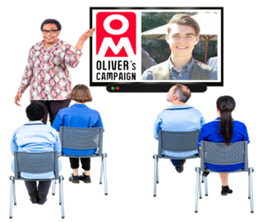 | Co-Trainers will deliver the training in the same room as the learners.  There can be up to 30 learners at a time.  Learning Disability Co-Trainers train on Learning Disability.  Autistic Trainers train on Autism.
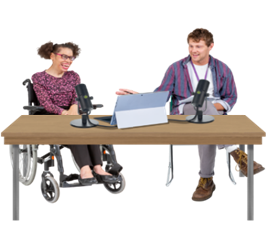 | Co-Trainers work with another trainer to support them to deliver the session.
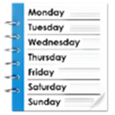   | Hours of work  There are not set days or hours you will work.  Instead, you will be offered work when DAD has it and then you can decide if you want to do it or not.  Once you have agreed to work on a certain day you must do that unless there is a good reason why you cannot.  Your manager will help you understand more about this.  On days you are asked to come to work to deliver training you will probably work between 4 to 7 hours a  day.  A Learning Disability trainer works  on a morning and Autistic Trainers  work on the afternoon.
 | Salary/Pay  Co-Trainers who are qualified as an Oliver McGowan Mandatory Trainer will be paid £13.05 per hour and a holiday allowance of £1.58 per hour = £14.63 per hour in total.  Co-Trainers who are training to be qualified will be paid £12.21 per hour and £1.48 holiday allowance per hour = £13.69 per hour in total.

A holiday allowance is paid this way because this is a casual job. It helps to keep things fair compared to other staff on different types of contracts.

Darlington Association on Disability

Job Description

Job Title: Co-Trainer

About the Job: We are looking for someone who is Autistic or is a person who has a learning disability or both.
You will help deliver training to people who work in health and social care.
The training is called The Oliver McGowan Mandatory Training on Learning Disability and Autism.
This training helps staff understand how to better support autistic people and people with a learning disability.

Salary/Pay: When training to be a Co-Trainer you will be paid £12.21 per hour, plus £1.48 holiday allowance per hour = £13.69 per hour in total.
When you are a qualified Co-Trainer you will be paid £13.05 per hour plus a holiday allowance of £1.58 per hour = £14.63 per hour in total.
Hours of Work: Casual hours as needed. When delivering training the working hours will be between 4 to 7 a day.
(The Learning Disability trainer works on a morning, Autistic Trainer works on the afternoon).

Pension: DAD operates a pension scheme for employees

Other: A competitive sickness scheme is available after working for a certain amount of time for D.A.D.
Staff can use an Employee Assistance Scheme and GP Helpline if they would like to.
More information will be given about this.

Responsible to: Senior Development Manager

Place of work: Based at Whessoe Technology Centre, Darlington.
Travel is expected across Darlington and Tees Valley, maybe further on occasion.

What You Will Do
- Work with other trainers to deliver training sessions
- Share your own experiences to help others learn
- Help make the training interesting and easy to understand
- Support people to learn how to communicate better with autistic people and people with learning disabilities

Who We Are Looking For
Someone who:
- Has lived experience as an Autistic person or a person who has a learning disability
- Likes talking to people and sharing their story
- Can work as part of a team
- Wants to help make health and care services better

Support and Training
- You will get training to help you do the job
- You will work with a team who will support you
- We will make changes to help you do your job well (this is called reasonable adjustments)

What’s Good About This Job
- You will help make a difference in people’s lives
- You will be part of a friendly and supportive team
- You will help others understand autism and learning disability better

